Analysis and design of a buck-boost converter: A buck-boost converter is illustrated in Fig. 2.28(a), and a practical implementation using a transistor and diode is shown in Fig. 2.28(b).

Fig. 2.28 Buck-boost converter of Problem 2.1:
(a) ideal converter circuit,
(b) implementation using MOSFET and diode.
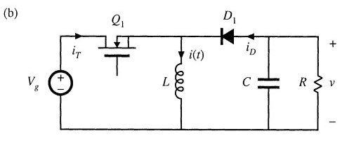
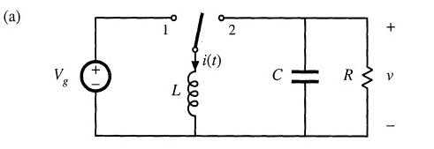

(a) Find the dependence of the equilibrium output voltage V and inductor current I on the duty ratio D, input voltage V, and load resistance R. You may assume that the inductor current ripple and capacitor voltage ripple are small.
(b) Plot your results of part (a) over the range 0 ≤ D ≤ 1.
(c) Dc design: for the specifications
Vin = 30 V
R = 4 Ω
V out = -20 V
f = 40 kHz
(i) Find D and I
(ii) Calculate the value of L that will make the peak inductor current ripple Ai equal to ten per- cent of the average inductor current I.
(iii) Choose C such that the peak output voltage ripple Av is 0.1 V

D=0.6
I=5A
L is 179micro
C is 250micro

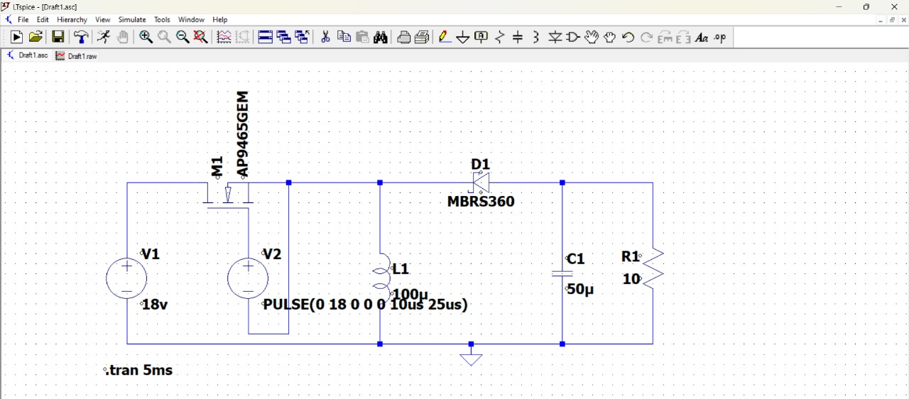

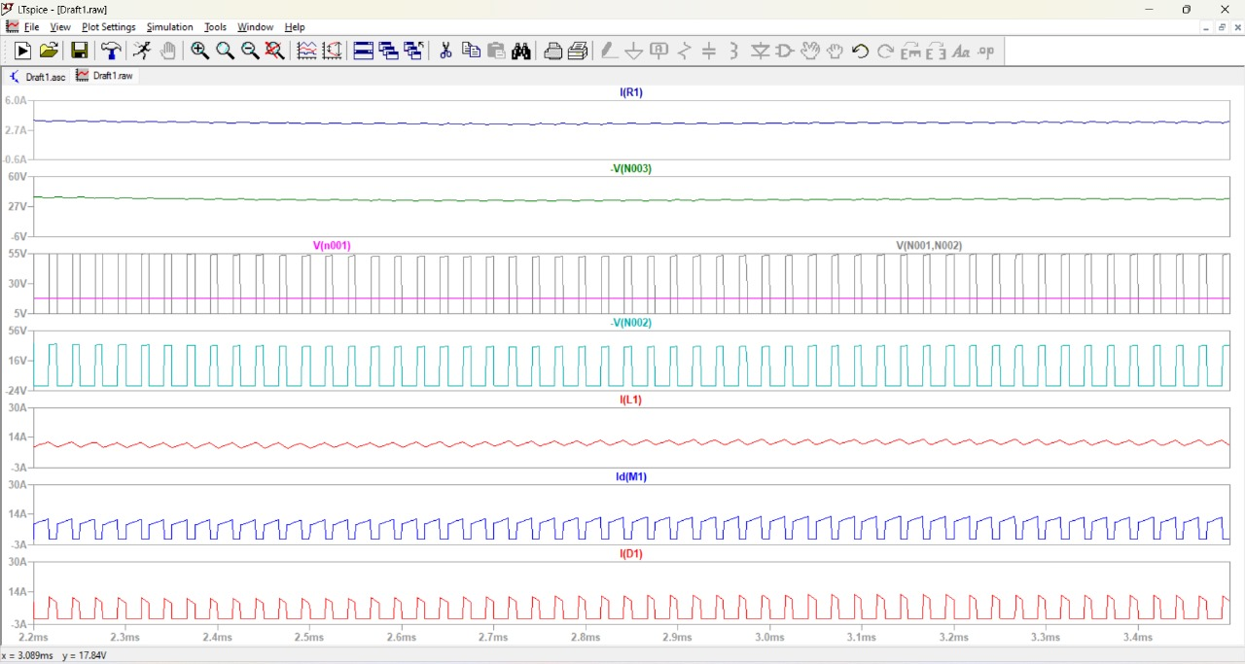
Boost
Vin = 18v
Vout = 35v
Iout = 3A
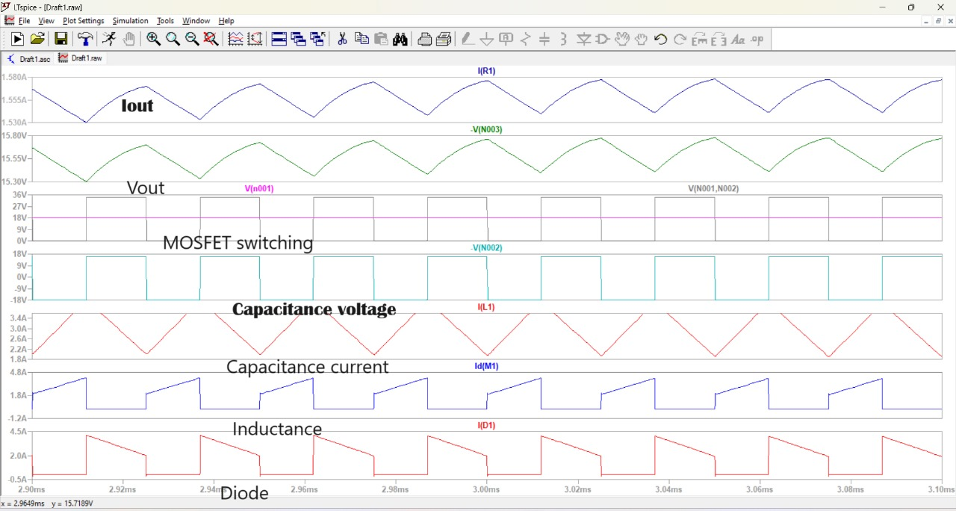
Buck
Vin = 18v
Vout = 15v
Iout = 1.3Amps

